P
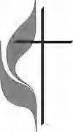

Union Chapel United Methodist Church

At Union Chapel, We Love Big In Our Small Way
December 4, 2022
Second Sunday of Advent ~ Peace
Prelude
Lighting Altar Candles
Welcome and Announcements
Opening Prayer
Advent Reading ~ Lighting the Advent Candle
Time of Fellowship
*Call to Worship
L: Come! Let us adore Him!
P: In the beginning was the Word,
And the Word was with God, And the Word was God,
He was with God in the beginning.
L: Through Him all things were made;
without him nothing was made that has been made.
in Him was life, and that life was the Light of Men.
ALL: Come! Let us adore Him!
L: The light shines in the darkness,
but the darkness had not understood it.
P: He was in the world,
and though the world was made through Him,
the world did not recognize Him.
L: He came to that which was His own,
but His own did not receive him.
ALL: Come! Let us adore Him! Let us adore Him!
L: The Word became flesh and made his dwelling among us.
P: We have seen his glory, the glory of the One and Only,
who came from the Father, full of grace and truth.
ALL: Come! Let us adore Him!
L: From the fullness of His grace we have all received one
blessing after another. Come! Let us adore Him!
P: Let us adore Him!
ALL: Come! Let us adore Him!

*Opening Hymn It Came Upon a Midnight Clear v1,2,4 #218
Scripture Reading Romans 15: 4-13 page 1411 in the pew Bible
Leader: This is the word of the Lord.
People: Thanks be to God
Joys and Concerns
Pastoral Prayer
*Doxology
*Offertory Prayer
Hymn Come Thou Font of Every Blessing v 1,3 #400
Holy Communion page 9 in hymnal
*The Gospel Lesson Matthew 3:1-12
page 1201 in the pew Bible
Leader: This is the word of the Lord.
People: Thanks be to God
Message “The Way"
*Closing Hymn Hark the Herald Angels Sing v 1,3 #240
Benediction
* Please stand if you are able.
† † † † † † † † † † † † † † † † † † † † † † † †
- MARK YOUR CALENDAR
December 14 ~ Administrative Board at 6pm
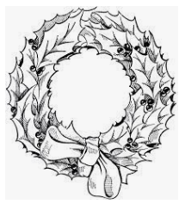
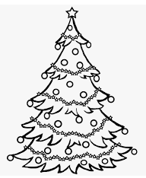
Joint Christmas Eve Service with Pleasant Mills
Here at Union Chapel ~ 4:00, fellowship following
Community Welcome
Worship Servants
Pastor John McCullough ~ (260) 223-2872
Email ~ john.mccullough@inumc.org
Accompanist: Becky Goble
Junior Church: Joan Falk
Communion Steward: Vicki Milholland
Website ~ www.unionchapelumcdecatur.org

